PCC Logo**PASADENA AREA COMMUNITY COLLEGE DISTRICT**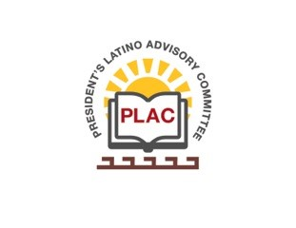

**President’s Latino Advisory Committee (PLAC)**

**Mission:** *To enhance the success of Latino students at PCC*

**Wednesday, June 19, 2019, 10:00 AM**

Pasadena City College

President’s Conference Room

1570 East Colorado Boulevard, Pasadena, CA 91106

1. Welcome and Introductions
2. Approval of Minutes: May 15, 2019
3. President’s Report (Erika Endrijonas)
4. Reports
   1. Noche de Excelencia: PLAC Annual Scholarship Dinner Report-back (Tito & Mika)
   2. Year-End Celebrations Report-back (Mika & Tito)
   3. Equity Plan Preview (Mika & Olivo)
   4. LatinX Graduates (Olivo)
5. New Business
6. Around the Table
7. Announcements
8. Adjourn