PCC Logo**PASADENA AREA COMMUNITY COLLEGE DISTRICT**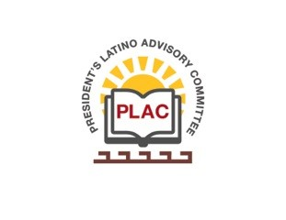

**President’s Latino Advisory Committee (PLAC)**

**Mission:** *To enhance the success of Latino students at PCC*

**Wednesday, March 20, 2019, 2018 10:00 AM**

Pasadena City College

President’s Conference Room

1570 East Colorado Boulevard, Pasadena, CA 91106

1. Welcome and Introductions
2. Approval of Minutes: February 20th, 2019
3. President’s Report (Erika Endrijonas)
4. Reports
5. New Business
6. Around the Table
7. Announcements
   1. Cynthia Olivo elected as Community Marshal at the 21st Pasadena Latino Heritage Parade and Festival on October 19th, 2019
8. Adjourn

**Next Meeting Date: Wednesday, April 17th, 2019**