PCC Logo **PASADENA AREA COMMUNITY COLLEGE DISTRICT**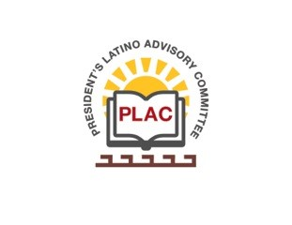

**President’s Latino Advisory Committee (PLAC)**

**Mission:** *To enhance the success of Latino students at PCC*

**Wednesday, November 21, 2018 10:00 AM**

Pasadena City College

President’s Conference Room

1570 East Colorado Boulevard, Pasadena, CA 91106

1. Welcomes and Introductions (10:25am)
   1. We welcomed Trustee Hoyt Hilsman to PLAC
2. Approval of Minutes: October 17, 2018 **(APPROVED)**
3. President’s Report (Rajen Vurdien)
   1. Richard Laret is our new Director of Facilities. He began on October 15th of this year.
   2. Mr. Bob Blizinski, with the approval of the Board, will be the new VP of HR at Pasadena City College and will begin next week.
   3. UCLA has sent numbers of how many students transferred to their campus
      1. 280 Students transferred
      2. 1050 applied
      3. 178 Honor Students applied
      4. 149 got accepted
   4. Our nursing students took the RN Exam and our success rate is 97%
   5. We will be hosting a luncheon of all the Superintendents/ Principles coming to campus on October 30th
4. Reports- VP of Instruction: Terry Giugni
   1. Dr. Giugni joined today’s PLAC meeting to give us an update in his area of Instruction at PCC. He went over the vision for Success which comes down to six components:
      * 1. Increasing completion
        2. Increasing Transfer rates
        3. Decreasing time for completion
        4. Focusing on CTE Students
        5. Reducing Equity Gaps
        6. Reduce the regional achievement gaps
   2. Bridging the gap between students and professors to speak out when they need to challenge grades, or classes etc. Help them have open communication when they need help in achieving the goal of transferring or getting that degree.
5. Adjourn: 11:33am