PCC Logo **PASADENA AREA COMMUNITY COLLEGE DISTRICT**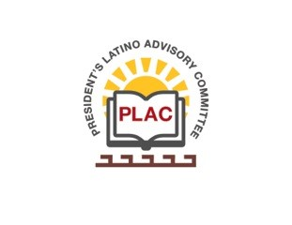

**President’s Latino Advisory Committee (PLAC)**

**Mission:** *To enhance the success of Latino students at PCC*

**Wednesday, August 15, 2018 10:00 AM**

Pasadena City College

President’s Conference Room

1570 East Colorado Boulevard, Pasadena, CA 91106

1. Welcome and Introductions
2. Approval of Minutes: July 18, 2018
3. President’s Report (Rajen Vurdien)
4. Reports
5. Meeting Schedule:
   1. September 19
   2. October 17
   3. November 21
   4. December 19
6. New Business
   1. Marketing efforts at PCC (Alex Boekelheide)
   2. President’s hiring update
7. Around the Table
8. Announcements
9. Adjourn