PCC Logo **PASADENA AREA COMMUNITY COLLEGE DISTRICT**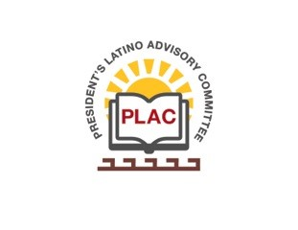

**President’s Latino Advisory Committee (PLAC)**

**Mission:** *To enhance the success of Latino students at PCC*

**Wednesday, July 18, 2018 10:00 AM**

**President’s Conference Room**

**Members in attendance:** J. Carreon, A. Chavez, V, De La Cuba, D. Leyba, M. Mares-Tamayo, S. Murga, I. Ocegueda, Y. Parada, H. Rodriguez, R. Vurdien

**Welcome and Introductions**

President Vurdien welcomed Dr. Isela Ocegueda, Dean of English to the committee.

Summer is in full swing. With the state’s new funding formula, PCC will be receiving additional funds, which the college plans to use towards the construction of the U building. Construction on the U building won’t begin until Spring 2020.

Community college districts cannot recruit students outside of their district. The population of our district 406,000 students, which includes all surrounding areas of Pasadena: South Pasadena, Arcadia, Rosemead, Altadena, etc. There are only 10,104 students who are in-district students and out of that, 38% are Latino.

The college is hiring 31 full-time faculty. The VP of Human Resources position is in the process of being filled. Executive Director of Facilities is currently being flown; Dean’s positions are currently being flown and we anticipate to have them filled by February 2019.

Dr. Olivo mentioned the IT building is currently being remodeled to accommodate all students to obtain a goal with the economic and workforce department. The Student Services area will also be renovated with a new workflow. The L building will have the “Apple store” layout where college administrators will approach students and see how they can help, rather than the student trying to figure which line to stand in.

The Welcome Center has been moved from Harbeson Hall to its new location in the Wi-Fi Center.

The Veterans Resource Center will be available in the next couple of months.

During the Board of Trustees meeting tonight, the Board will be approving the contract with John Muir High School to offer credit/non-credit career technical classes and life-long classes.

Dr. Olivo has applied and received a grant - “Promises that Count” which is a program that begins in middle schools and lets the students understand and learn about the opportunities that PCC has to offer early on.

**Future Meeting Date:**   
Wednesday, August 15, 2018 at 10:00 a.m.