PCC Logo **PASADENA AREA COMMUNITY COLLEGE DISTRICT**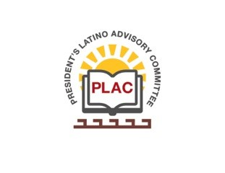

**President’s Latino Advisory Committee (PLAC)**

**Mission:** *To enhance the success of Latino students at PCC*

**Wednesday, March 14, 2018 10:00 AM**

Pasadena City College

President’s Conference Room

1570 East Colorado Boulevard, Pasadena, CA 91106

1. Welcome and Introductions
2. Approval of Minutes: December 13
3. President’s Report (Rajen Vurdien)
4. Reports
5. Scholarship Update
6. Meeting Schedule:
   1. June 13, 2018
   2. September 12, 2018
   3. December 12, 2018
7. Around the table
8. New Business
   1. Mission Statement Review – Crystal Kollross
   2. MPYD – Javier Gil
   3. Latina Leadership – Stella Murga
9. Announcements
10. Adjourn