PCC Logo **PASADENA AREA COMMUNITY COLLEGE DISTRICT**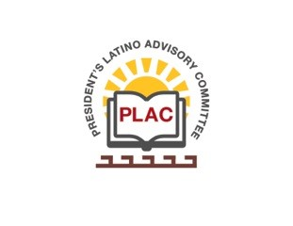

**President’s Latino Advisory Committee (PLAC)**

**Mission:** *To enhance the success of Latino students at PCC*

**Wednesday, December 13, 2017, 10:00 AM**

**President’s Conference Room**

**Members in attendance:** C. Altamirano, J. Carbajal-Ramos, G. Caringella, A. Chavez, J. De La Cuba, J. Gil, G. Herrera, D. Leyba, K. Lopez, M. Mares-Tamayo, M. Morales, C. Olivo, Y. Parada, J. Perez, L. Romero, R. Vurdien

**Welcome and Introductions**

President Vurdien announced Dr. Sandra Serrano from Collaborative Brain Trust, the Presidential search consultant will be meeting with this group shortly.

Dr. Vurdien reported last week the scholarship ceremony was a huge success. Over $288K in scholarships were given out to well-deserved students. In total, $750K has been given out by the college for scholarships. PCC Foundation has raised $7 million dollars already for the Major Gifts Campaign.

Other great news, the college is eligible for the 2019 Aspen Award. The application has been completed and is in process; we will find out later next year, if PCC is a finalist.

Dr. Vurdien reported enrollment is slightly higher than last year; the college is looking forward to the winter session and spring enrollment looks higher than last spring.

The college has hired 20 new faculty; currently there are 427 full-time faculty members. There are a couple of vacancies - Executive Director of HR, Executive Director of Information Technology, and Executive Director of Facilities.

President Vurdien mentioned the state has passed a new law which lays the groundwork to waive the fees for the first year of community college for all first-time students. It's an incentive that would draw in new students who wouldn’t otherwise enroll. This new program would cost the state $31 million. PCC has launched its Promise Program – first year is free for first time incoming students that are in-district. This program will be effective Fall of next year if the Foundation Board approves it.

Members of the committee had a discussion about cultural competencies and professional development training among the diverse population group’s campus wide.

**EEO Plan**The Board of Trustees approved the Equal Employment Opportunity Plan and it was adopted June 2, 2017. Dr. Vurdien expressed the college’s commitment to a diverse community and environment. The college has invested more than $1 million dollars for appropriate training.

Director of Student Equity M. Mares-Tamayo was hired to ensure the college is on right track.

**Future Meeting Date:**   
Wednesday, June 13, 2018 at 10:00 a.m.