PCC Logo**PASADENA AREA COMMUNITY COLLEGE DISTRICT**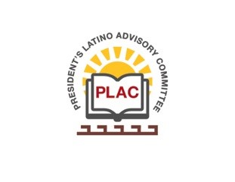

**President’s Latino Advisory Committee (PLAC)**

**Mission:** *To enhance the success of Latino students at PCC*

**Wednesday, April 21, 2021**

**10:00 AM – 11:30AM**

Pasadena City College

Zoom Meeting

1. Welcome and Introductions
2. Approval of Minutes (March 17, 2021)
3. President’s Report (Erika Endrijonas)
4. Lancer Care Presentation (Carmen Stephens)
5. Reports
6. Announcements
7. Adjourn