PCC Logo**PASADENA AREA COMMUNITY COLLEGE DISTRICT**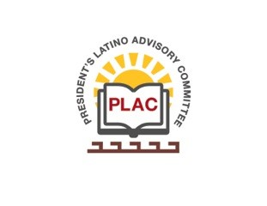

**President’s Latino Advisory Committee (PLAC)**

**Mission:** *To enhance the success of Latino students at PCC*

**Wednesday, March 17, 2021**

**10:00 AM – 11:30AM**

Zoom Meeting

**Members Present**: R. Aceves, M. Alvarez, C. Altamirano, G. Caringella, A. Chavez, E. Endrijonas, D. Hernandez, M. Mares-Tamayo, S. Miranda, S. Murga, I. Ocegueda, C. Olivo, Y. Parada, I. Ramirez, D. Rescarte, C. Salazar-Romo, S. Toscano

1. **Welcome and Introductions** at 10:05AM
2. **Approval of Minutes** (January 20, 2021 & February 17, 2021)- Approved
3. **President’s Report** (Erika Endrijonas)
   1. The ACCJC comprehensive visit concluded last week with a report out on March 11th by the visiting team chair, Dr. Edward Bush. There is one potential area of recommendation regarding disaggregating student learning outcome data, which was already identified as an area of improvement by the college. Pasadena City College (PCC) received three proposed commendations in the following areas:
      1. An all-around equity-minded culture at the college.
      2. Professional development for adjunct faculty.
      3. FYE program expansion scaled up to include all students.
   2. The Higher Education Emergency Relief Fund (HEERF II) signed in December 2020, will provide $30 million in federal aid funds of which $10 million will be spent on direct student aid.
   3. President Biden signed the $1.9 trillion American Recovery Plan Act of 2021 (HEERF3), which includes funding for community colleges; PCC will receive $52 million to spend by September 30, 2023.
   4. Governor Newsom signed an early action bill, which has an apportionment for reopening schools, from which PCC will probably receive about $2 million.
   5. The Sarafian Building is officially under construction and a certificate of participation for $27 million was pulled to cover the cost of the building.
   6. The upcoming Partnership Resource Team (“PRT”) visit will focus on improving campus collegiality, which was one of the topics identified in the Quality Focus Essay. The college will receive $200,000 to implement the team’s recommendations.
   7. The Vice President of Business and Administrative Services, Dr. Mike Bush, will be retiring at the end of April.
4. **Curriculum Redesign & Career First Curriculum – Title V Grants** (Ocegueda, Mares-Tamayo, Salazar-Romo, Toscano)
   1. A presentation on the overview of Title V Grants was presented to the group.



1. **Reports** 
   1. Olivo provided the following report:
      1. Data was shared on the number of students not returning to college. With the additional funding, PCC will need to have a targeted outreach approach to find out what students need to come back.

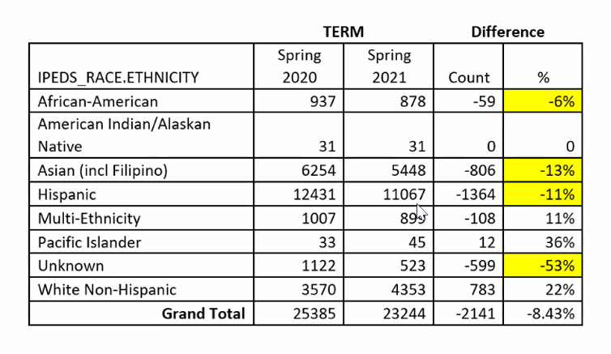

* + 1. Olivo proposed student care teams with the following responsibilities:

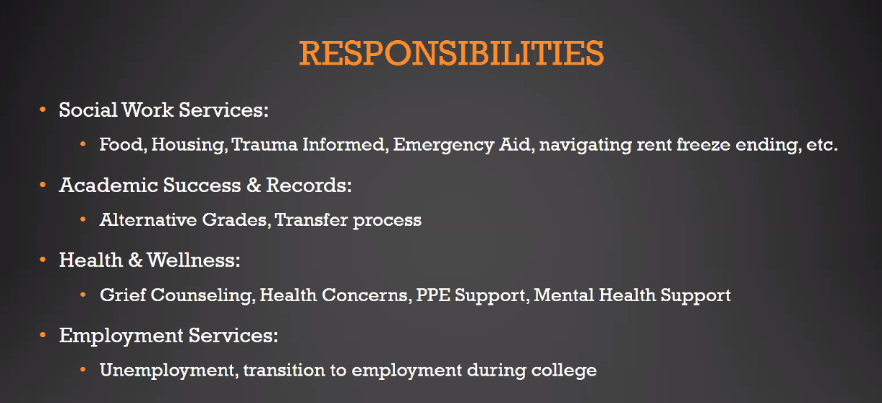

* + 1. A survey will be sent out to students to determine what they want for fall. Mares-Tamayo stated that students had shared they were struggling with finances last year and therefore, a lot of the CARES funds were allotted for direct student aid.
  1. Recarte gave a report on the many events being hosted by the PCC QUEST Center, which can be accessed through their [Linktree](https://linktr.ee/questcenter).
  2. Melva provided the following ALE report:
     1. The ALE Muerto is scheduled for March 24th at 12:00PM.
     2. The PLAC scholarship applications are live. The virtual ceremony is scheduled for May 25th at 6:00PM.
  3. Murga reported that tutoring is still being offered and students undergoing extraordinary stress are being identified in order to be referred to a therapist.

1. **Announcements**
   1. Salazar-Romo submitted information on PCC’s efforts during this pandemic to Excelencia in Education.
2. **Adjourn** at 11:30AM