PCC Logo**PASADENA AREA COMMUNITY COLLEGE DISTRICT**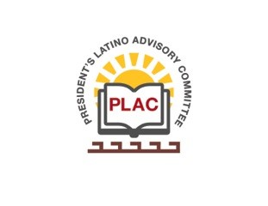

**President’s Latino Advisory Committee (PLAC)**

**Mission:** *To enhance the success of Latino students at PCC*

**Wednesday, March 17, 2021**

**10:00 AM – 11:30AM**

Pasadena City College

Zoom Meeting

1. Welcome and Introductions
2. Approval of Minutes (January 20, 2021 & February 17, 2021_
3. President’s Report (Erika Endrijonas)
4. Curriculum Redesign & Career First Curriculum – Title V Grants (Ocegueda, Mares-Tamayo, Salazar-Romo, Toscano)
5. Reports
6. Announcements
7. Adjourn