PCC Logo**PASADENA AREA COMMUNITY COLLEGE DISTRICT**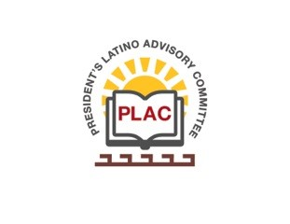

**President’s Latino Advisory Committee (PLAC)**

**Mission:** *To enhance the success of Latino students at PCC*

**Wednesday, February 17, 2021**

**10:00 AM – 11:30AM**

Pasadena City College

Zoom Meeting

1. Welcome and Introductions
2. President’s Report (Erika Endrijonas)
3. Reports
4. Announcements
5. Adjourn