PCC Logo**PASADENA AREA COMMUNITY COLLEGE DISTRICT**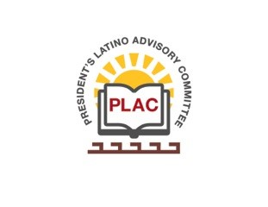

**President’s Latino Advisory Committee (PLAC)**

**Mission:** *To enhance the success of Latino students at PCC*

**Wednesday, February 19, 2020**

**10:00 AM – 11:30AM**

Pasadena City College

President’s Conference Room

1570 East Colorado Boulevard, Pasadena, CA 91106

1. Welcome and Introductions
2. Approval of Minutes- January 15, 2020
3. FMP Presentation
4. President’s Report (Erika Endrijonas)
5. Reports
6. Announcements
7. Adjourn