PCC Logo**PASADENA AREA COMMUNITY COLLEGE DISTRICT**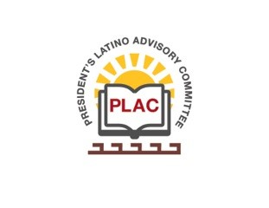

**President’s Latino Advisory Committee (PLAC)**

**Mission:** *To enhance the success of Latino students at PCC*

**Wednesday, October 16, 2019**

**10:00 AM – 11:30AM**

Pasadena City College

President’s Conference Room

1570 East Colorado Boulevard, Pasadena, CA 91106

1. Welcome and Introductions
2. Approval of Minutes: August 21, 2019 and September 18, 2019
3. President’s Report (Erika Endrijonas)
4. Educational Master Plan (Crystal Kollross)
5. Reports
6. New Business
7. Around the Table
8. Announcements
9. Adjourn